Young Adult Pilgrimage for Peace (YAPP) 2026 by George Oworae Danquah
I was excited about the YAPP opportunity for two main reasons. First, I looked forward to travelling abroad, experiencing a new country, and visiting different cities. However, on my very first day in Colombia, I heard words that immediately challenged my expectations: "You are not here as a tourist." I was stunned. Rev Kim Yang Jin (Liaison for Peace and Justice at the General Board of Global Ministries, United Methodist Church) then explained, in simple but profound terms, the difference between a tourist and a pilgrim. A tourist primarily seeks experiences and enjoyment, whereas a pilgrim seeks transformation. A pilgrim leaves home with an open heart, listens with humility, laments and shows empathy for the suffering of others, responds to injustice, and returns home changed, committed to living as a peacemaker and encouraging peacebuilding. We were introduced to what Rev Kim called the five L's of a Pilgrim:
- Leave home with an open heart.
- Listen with humility.
- Lament and show empathy.
- Liberate by responding to injustice.
- Live differently by returning home transformed and becoming a peacemaker.
This reshaped my understanding of why I was in Colombia and set the tone for everything that followed.
I was also excited because of the work I have been doing through All Our Shoes, the charity I founded in 2024 while volunteering at Coventry Central Hall. Our mission is to raise awareness of the challenges faced by vulnerable people in our communities and to journey alongside them with compassion, dignity, and hope. Through this work, I have come to appreciate that genuine support begins with being present. Walking alongside people, listening deeply to their stories, and sharing in their joys and struggles—what I often describe as a ministry of presence—is essential if we are to understand their lived experiences.
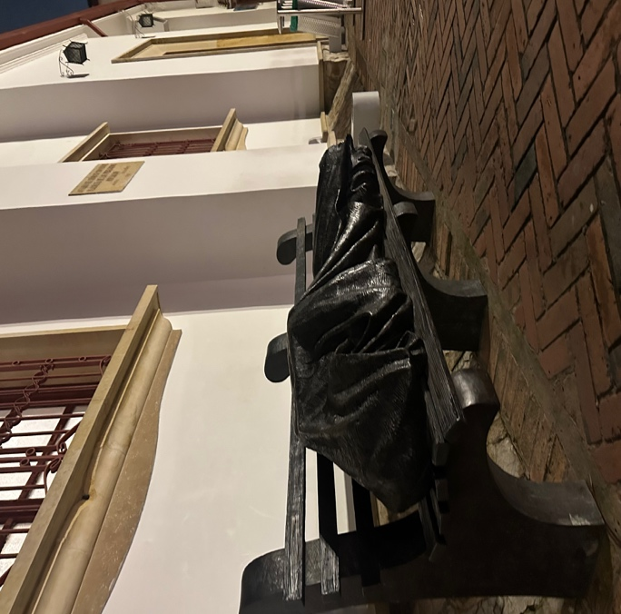
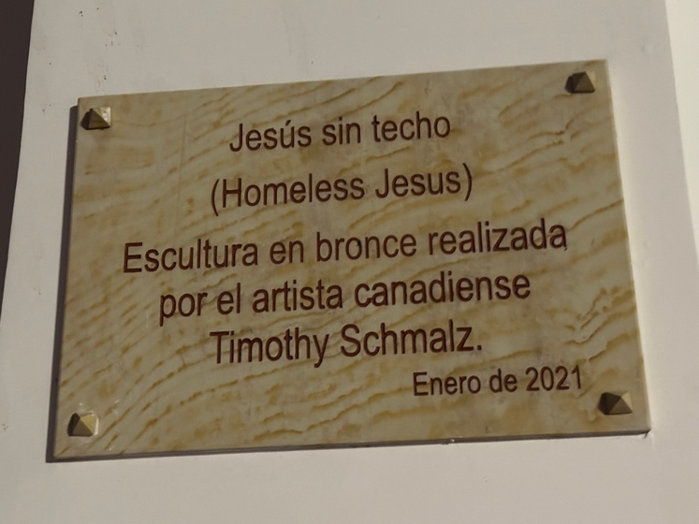

Figure 1. Image of the Homeless Jesus sculpture, depicting Jesus sleeping rough on a public bench. The artwork serves as a reminder of Jesus’ identification with the most vulnerable members of society.
This understanding has also been shaped by the example of Jesus Christ. In Philippians 2:6–7, Paul writes that although Jesus was in very nature God, he "did not consider equality with God something to be used to his own advantage; rather, he made himself nothing by taking the very nature of a servant." Christ entered our world and chose to be with humanity. He lived among ordinary people, experienced their struggles, and met them where they were. Because He knew people's hearts and understood their thoughts (Matthew 9:4), His ministry was, and is always personal, compassionate, and responsive to our deepest needs. With this perspective, my journey to Bogotá, Cali, and the visit to Siloé became much more than an opportunity to travel. They became gentle invitations to see, to listen, and to learn.
I wanted to understand, from the Colombian perspective, what peace really means. How do people who have lived through conflict, displacement, inequality, and reconciliation understand peace? Is peace simply the absence of violence, or is it something deeper? These were the questions I carried with me as I embarked on this pilgrimage.

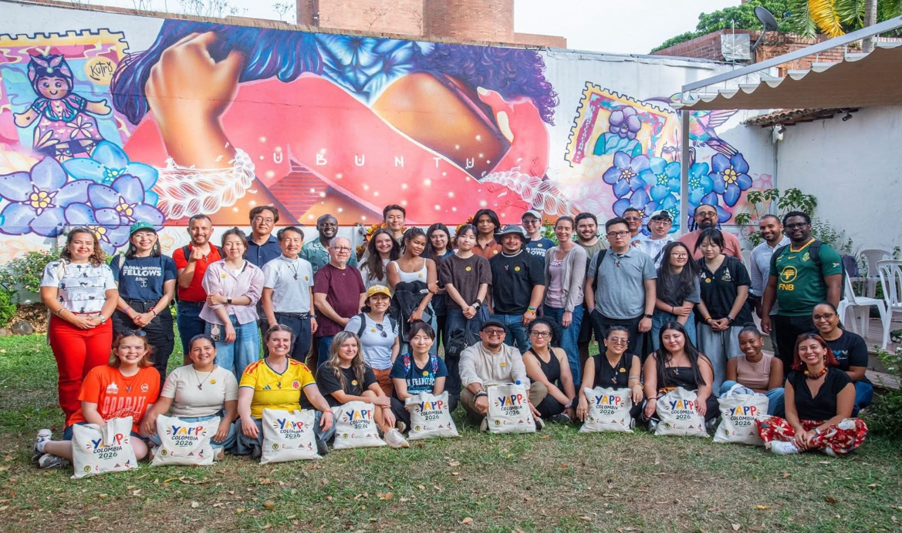
Figure 2: Group picture with all participants at the House of Memories of Conflict and Reconciliation (Casa de las Memorias del Conflicto y la Reconciliación) in Cali.

I thank the World Methodist Council, the Methodist Church in Britain, and the Coventry and Nuneaton Methodist Circuit for this opportunity.

Prayer:
Lord send us into the world as Pilgrims for Peace; until all are fed, until all belong, and until Your peace embraces the whole world, in Jesus’ name, amen.

